**Real-State Property Management**

**Student Name:**

**Student ID:**

Contents

Introduction: 3

Database design and implementation: 3

Entity Identification: 3

Attribute Definition: 4

Entity Relation Diagram: 5

Normalization: 6

Data Population: 7

Query Development: 9

Conclusion: 12

References: 13

# **Introduction:**

In the realm of modern technology where new inventions are made all the time. Day by day something new is developed in the field of computer science. Whether this development is related to the data field or any other field. So for this assessment, the main topic is related to databases so first see what is data. Data is the raw, facts of the figure, in simple words any sort of information or anything is called data. This data is very important for everyone because in this data all the information includes personal information, work-related information, etc.

Let's take an example of a company, a company has a lot of data from past years and this company has to store their data, so the data may be safe in storage or no one can steal or see that data. Because in this data, all the information related to the company’s employees, company projects, and their customer’s information is stored. So for their customer satisfaction, all the companies want their day should be kept private to prevent external threats and save them from cyber-attacks. In past years there has been no source of protecting or storing data efficiently but in the modern era, developers have built a system that handles all the data and allows to manipulation of the data as well with the help of queries. This data is stored very efficiently and managed by the company owner. The database uses SQL language and there are a lot of commands that can say quires by which can handle all the data. The database makes everything easy and enhances the accuracy of the work.

In this assessment the topic is real state property management, the database includes all the related entities and their respective attributes to store the valuable data. The database is created with the help of the MySql Workbench Software tool. This report is very beneficial if someone wants to understand how databases are integrated into property management.

# **Database design and implementation:**

In this implementation phase include all the things like first identifying all the entities and their attributes and second normalization then at last creating an entity relation diagram.

### **Entity Identification:**

* ***Customer***
  + It stores all the information of the customer which are needed to store for example customer’s personal information and other details.
* ***Property***
  + It stores all the information and details about the property.
* ***Agent***
  + This table stores information related to agents which agents work on which phase each and everything is stored in this table.
* ***Sale***
  + The information related to sales is stored in this table which includes information related to payments and sales.
* ***Lease***
  + Information related to property leases is stored here.
* ***Payment***
  + Payment information for which payment is cleared and which are pending all are stored in this table.
* ***Owner***
  + The information about owners is stored in this table.
* ***Property Owner***
  + Relationships between property and owners are listed in this table.

### **Attribute Definition:**

In this section of the report, all the attributes of the tables with their entity name are listed here so the reader can easily understand the attributes and their table names.

* ***Customer***:

The customer table includes a customer ID (Primary key), Name of the customer, email, and phone number.

* ***Property***

The property table includes a property ID (Primary Key), address of the property, zip code, city, state, price, and last information of the agent which are given from the agent table with the help of Agent ID (Foreign Key).

* ***Agent***

The agent table includes the agent ID (Primary key), name of an agent, phone, and last attribute of its email (*Azzahra, Z.F. and Anggoro, A.D., 2022*).

* ***Sale***

The sale table includes the Sales ID (Primary key), sale date, and sale price this table makes relation with two tables so one can get information from multiple tables with the help of their IDs Customer ID, and Property ID (foreign key).

* ***Lease***

This lease table includes the lease ID (Primary key), start date, end date, rent and two foreign keys (Customer ID, and Property ID).

* ***Payment***

This table includes payment ID (Primary key), payment date, amount, and relation with the lease table with the help of lease ID (foreign key).

* ***Owner***

The owner table includes the Owner ID (Primary key), name of owner, address, and phone.

* ***Property Owner***

This table includes 2 foreign keys property ID and Owner ID, ownership start date, and the last attribute ownership end date.

## Schema Creation:

In this section of the report, all the primary keys are defined in all the tables.

* ***Customer***:

customer ID (Primary key).

* ***Property***

Property ID (Primary Key), Agent ID (Foreign Key).

* ***Agent***

Agent ID (Primary key).

* ***Sale***

Sales ID (Primary key), and two foreign keys Customer ID, and Property ID (foreign key).

* ***Lease***

Lease ID (Primary key) and two foreign keys (Customer ID, and Property ID).

* ***Payment***

payment ID (Primary key), and one foreign key is lease ID (foreign key).

* ***Owner***

OwnerID (Primary key).

* ***Property Owner***

PropertyOwnerID (Primary Key)

All of the tables are connected with the help of these primary keys and this strategy improves the query performance and maintains data integrity as well.

# **Entity Relation Diagram:**

The entity relation diagram is considered one of the most important things in the creation of the database management system because it makes the work easy. It helps to identify all the related entities and their attributes. It also helps to find out the relation between entities and all the workflow of the database can be identified by using the entity relation diagram. The entity relation diagram makes the work easy to understand by the user because when users see the database workflow in the form of picture data, they can easily recognize that a customer table has a relation with sales and lease tables and payment tables have a direct connection with tables like lease, sales, agent and property owner (*Zhang, D., Gao, F, ELT 2020*). All of the relations can be easily identified that’s why entity relation diagrams have a lot of importance in the creation of the database.

One more advantage of this entity relation diagram in the context of the programmer's point of view is the programmer can make and select names of attributes and datatypes of attributes with the help of the entity relation diagram.

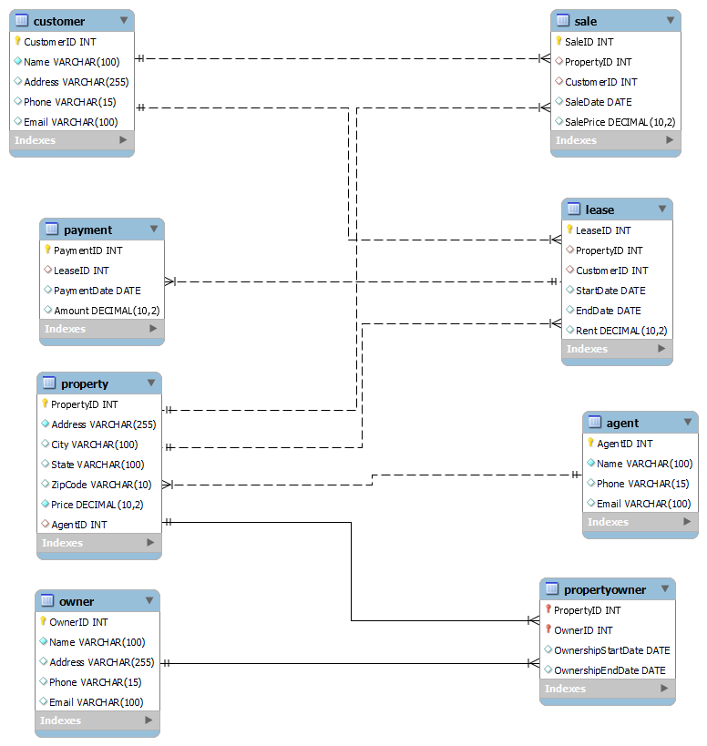

This entity relation diagram has 8 tables with their respective attributes and relation with other tables.

# **Normalization:**

***1NF***: All tables contain the primary keys (customer ID, agent ID, payment ID, property ID, owner ID, property owner ID, lease ID, sales ID), and all the fields in these tables have atomic values.

***2NF***: All the attributes of these tables are fully dependent of their primary keys *(Ogli, R.A.R., 2022*).

***3NF***: There are no transitive dependencies in these tables.

# **Data Population:**

All the data is inserted in their corresponding tables the stored data and their relative screenshots are pasted in this report so the reader can easily understand how to insert query works.

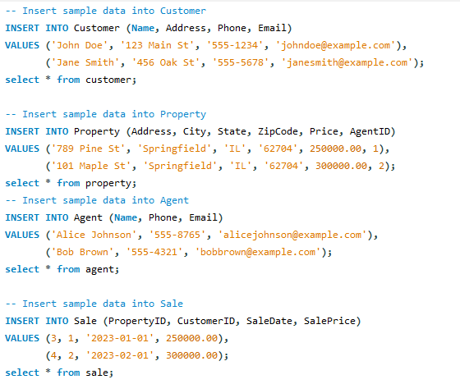

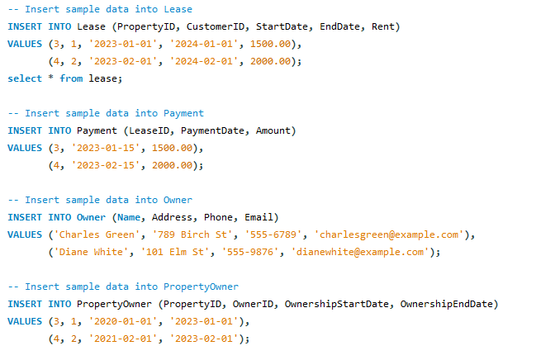

These are all 8 tables insert queries the data is added to their corresponding tables and all the queries are run without any issues.



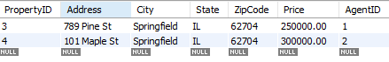



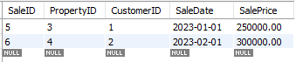



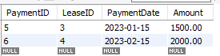





These are all the outputs of all the insert queries which are gotten with the help of the SELECT query to select all the data from all the tables one by one. All tables follow full normalization and work as expected. There are a total of 8 tables with their data as shown in the report ((*Azzahra, Z.F. and Anggoro, A.D., 2022*)).

# **Query Development:**

Now in this section of the report, all query results manipulate the data and find out the results from the table that are needed by the user, like if the user wants to search a specific field-related result, or user wants to add, update, delete records or user want anything else this section include all the quires based on the choice of the user. All the queries with their respective output are defined below:

***The first query is based on basic and conditional retrieval.***

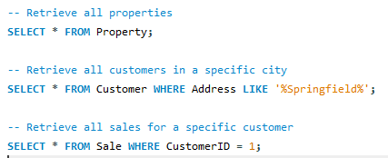

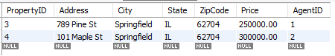



In this query the select command is used to retrieve all the data based on the WHERE clause the WHERE is used to set the conditions whether the condition is true it gives the output otherwise it gives the blank result.

***Aggregate Report:***

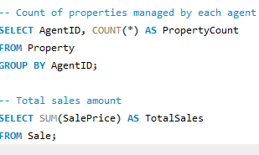

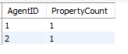



In this new command is used which is GROUP BY which groups agent ID and property count and gives an output in the form of a report then in the second query the select command is used with the sum operator which adds all the sales and gives a single output (*Chen, I.M.A., Chu, ELT 202*1).

***Data Manipulation:***

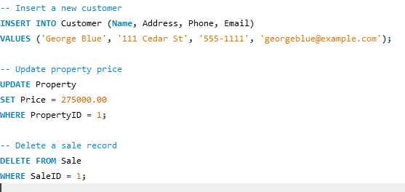

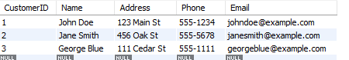

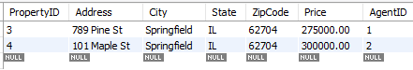

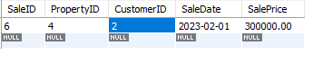

In these queries first is adding a new record in the customer table as George Blue and this record is successfully added then the price of the property where ID = 3 with the help of the UPDATE command at last delete a single record of sales o=with the help of DELETE command (*Elmasri, R., Navathe, ELT 2020*).

***Complex Queries:***

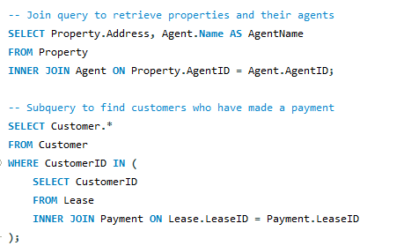

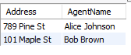

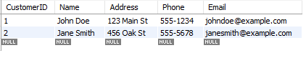

These are the logical queries that include the concept of joins. The JOIN command joins 2 tables and gives a single table output as expected.

# **Conclusion:**

This is the report which explains the database of the real estate management system. In real-state work, there is a need for a system which holds all the data and stores that data in a specific system where a user or owner of the business can easily see how their business will progress and how the data is stored in the database. The owner can easily see the information of their customers, their property all the sales and can easily insert, delete, and update the records as well. This report contains all types of queries and the report also contains a comprehensive entity relation diagram which makes it easy to understand how the database will integrate with this real estate management field. After reading this comprehensive report the reader can easily determine the importance of database in the field of real estate management.

# **References:**

Azzahra, Z.F. and Anggoro, A.D., 2022. Analisis Teknik Entity-Relationship Diagram dalam Perancangan Database Sebuah Literature Review. INTECH (Informatika dan Teknologi), 3(1), pp.8-11.

Chen, I.M.A., Chu, K., Palaniappan, K., Ratner, A., Huang, J., Huntemann, M., Hajek, P., Ritter, S., Varghese, N., Seshadri, R. and Roux, S., 2021. The IMG/M data management and analysis system v. 6.0: new tools and advanced capabilities. Nucleic acids research, 49(D1), pp.D751-D763.

Elmasri, R., Navathe, S.B., Elmasri, R. and Navathe, S.B., 2020, August. Fundamentals of Database Systems</Title. In Advances in Databases and Information Systems: 24th European Conference, ADBIS 2020, Lyon, France, August 25–27, 2020, Proceedings (Vol. 12245, p. 139). Springer Nature.

Ogli, R.A.R., 2022, February. The difference between the concepts of database and database management systems. In Archive of Conferences (pp. 33-34).

Zhang, D., Gao, F., Jakovlić, I., Zou, H., Zhang, J., Li, W.X. and Wang, G.T., 2020. PhyloSuite: An integrated and scalable desktop platform for streamlined molecular sequence data management and evolutionary phylogenetic studies. Molecular ecology resources, 20(1), pp.348-355.